Digital Footprint
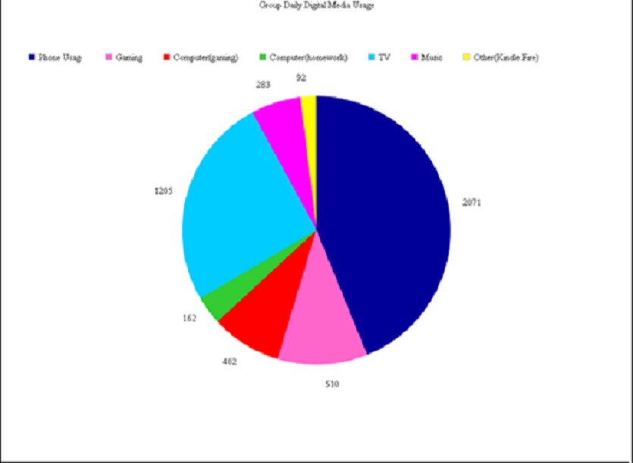

- Why did your group select this type of graph?

We chose this graph because we felt that the pie graph would show our information best.

- How is the digital footprint represented within your group?

